
The minutes of the Annual General Meeting of Satterthwaite Parish Council held in the Parish Room, Satterthwaite on Monday 8th June 2026 at 7.15 pm.
Minutes - AGM
Item
Elections
1 | Election of the Chairman  Grant Nickson – proposed by Gary Thomason and seconded by Mhari Crabtree
2 | Election of the Deputy Chair  Gary Thomason – proposed by Grant Nickson and seconded by Mhari Crabtree
Opening Administration

3 | Welcome and Introductions  Apologies  Emma Nield
4 | Declarations of interest  - To receive declarations by elected and co-opted members of disclosable pecuniary interests in respect of items on this agenda  None
5 | Requests for Dispensations  - The clerk to report any requests received since the previous meeting for dispensations to speak and/or vote on any matter where a member has a disclosable pecuniary interest.  None
6 | Minutes  - To authorise the Chair to review and sign the last AGM minutes from 30th June 2025 – agreed as accurate record  Agreed
Matters for consideration
7 | Public participation  - To receive comments and representations from members of the public in relation to any item on the agenda  None present
8 | Review of Policies  - Standing Orders  - Financial Regulations  - Reserves  - Transparency  - IT policy  - Personal data protection policy  - Grievance  - Dealing with media/press  - Code of conduct  To be agreed and signed off for 2026/2027 - all agreed. On website.
9 | Review of assets – asset register  Agreed as accurate and up to date.
10 | Review of insurance – Zurich  Agreed policy. Recently updated.
Finance
11 | Year-end accounts  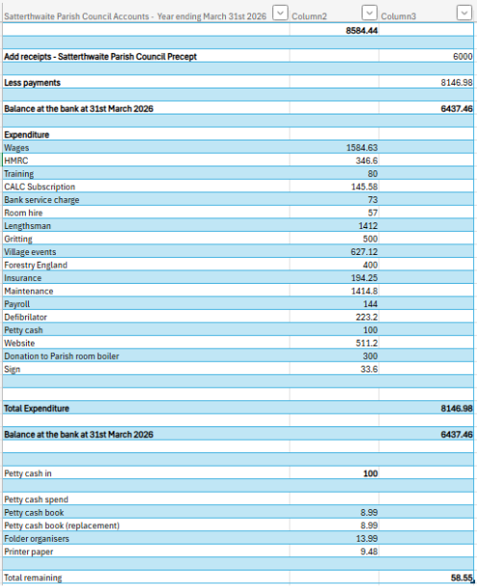  Agreed as accurate records for 25/26.
12 | Signatories for banking system – to review  Remove Helen Bright and add Howard Joseph.
13 | Unity bank  Happy with service. To continue.
14 | AGM date  Will be May 2027 – date to be confirmed nearer time.
Close

Minutes of the Satterthwaite Parish Council Annual General Meeting held on Monday 30 June 2025
Held in public in the Parish Room, Satterthwaite LA12 8LT
Commencing at 7:00pm
Present: Grant Nickson (GN - Chair)
Gary Thomason (GT - Deputy Chair)
Emma Nield (EN - Councillor)
Mhairi Crabtree (MC - Councillor)
Caroline Brock (CB - Clerk)
In attendance from the public: David Ham
David Robbens

1 Apologies
Received from Cllr Suzanne Pender

2 Elect a Chairman
GN prosed and seconded by GT
Decision: GN elected as Chair

GT proposed as Deputy Chair and seconded by EN
Decision: GT elected as Deputy Chair

3 Public Participation
Representatives from the public in attendance.

Meeting Closed at 7:15pm

Asset Register
Asset | Year acquired | Cost (£) | Replacement cost (£)
Land acquired on nursery lane for playground | 1983 | 300
Playground equipment |  |  | 50000
Land acquired behind church | 1985 | 1000

